Branding Specification

**of PeopleGoGo**

Current version: **1.0.2**

Author: **Pavel Tashev**

Created on: **29 Sep 2015**

# 

# 

# Content

Content

Changelog and future plan

Dependencies

The trademark PeopleGoGo

Introduction

Identificators

Logo

Logo - correct usage

Colourfull

Black and White

Logo - colour palette

Typography

Logo - incorrect usage

Slogan and keyphrase

Typography

Badges

Round badges

Example

Sizes

Square badge

Example

Sizes

Typography

Colour pallette

Social networks

Cover image

Profile image

Mobile applications

Icon

Website

Colour pallette

Fonts

Typical signs (Characteristics)

Associations

Communication with the client

Video advertisement

# Changelog and future plan

Use the changelog in order to trace the changes in the time.

| ***Version*** | ***Date*** | ***Changes*** |
| --- | --- | --- |
| *1.0.0* | 29 Sep 2015 | * The document is created.. |
| *1.0.0* | 08 Oct 2015 | * The content of the document was slightly changed. |
| *1.0.1* | 20 Oct 2015 | * First final version of the document. |
| *1.0.2* | 21 Oct 2015 | * The content was rearranged. * A new chapter “Badges” is added. * A future plan for the document, what elements and new chapters to add. |

# 

The future plan for document can be described in a list:

* Add the following chapters and modify the existing content:
  + The concept of the trademark
    - What is the trademark
      * Introduction
      * Identificators
      * Characteristics
      * Associations
    - The power of the trademark
      * Value for the client
      * Value for the organization
    - How to develop and manage a trademark
  + The trademark PeopleGoGo
    - *Add the chapters which have already been created. Change them if necessary. The chapter “Communication with the client” to be completed with more information.*
    - Audience *- who is our client, what are the needs of the client, how do we satisfy these needs.*
  + FAQs
* Change the name of the document to *“Brand book”*.
* For the future designs use *“golden ration”*.

# 

# 

# Dependencies

For better understanding of the current document please read the following documents:

* *“Business Plan”*

# 

# 

# 

# The trademark PeopleGoGo

## Introduction

In the next few chapters we will present the identificators and the association elements related to the brand *PeopleGoGo*. The idea of the identificators and the association elements is to connect them directly to the brand *PeopleGoGo* and all features and characteristics which it represents.



In short, within the next chapter we will present:

* the audience;
* the identificators;
* instructions for the graphical presentation - fonts, colours, etc.;
* the characteristics;
* the associations;
* the communication channels with the client - channels, how and where to advertise, how to talk and interact with the clients.

# 

# 

## Identificators

This chapter represents and the corporate design guideline.

### Logo

#### Logo - correct usage

##### Colourfull

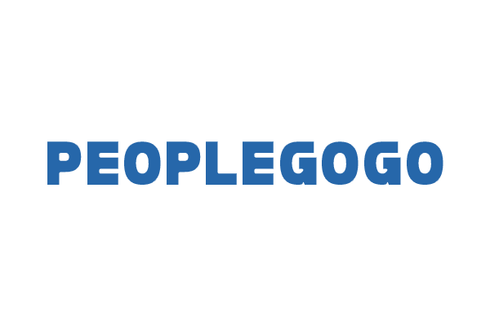

#### 

#### 

##### Black and White

Positive:

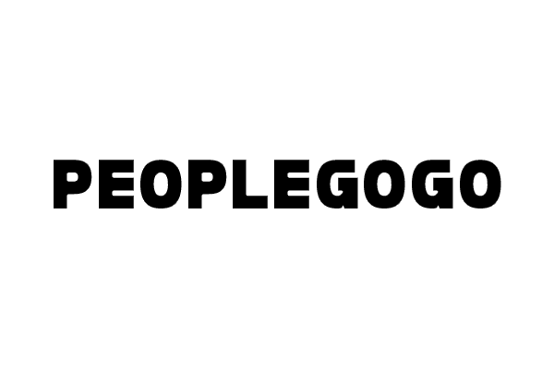

Negative:

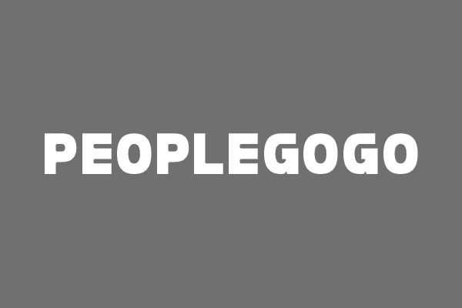

#### Logo - colour palette



#### Typography

For the logo use the font “Folklore”. We apply the following changes when we use this font for the logo:

Vertical scale: 100%

Horizontal scale: 85%

#### Logo - incorrect usage

Incorrect usages of the logo:

* Do not distort, scale or rotate the logo.
* Do not use non-approved colors.
* Do not alter the thickness of the logo.
* Do not reproduce in outline.
* Do not Use an unauthorized typeface.
* Do not alter the ratio between any part of the logo.
* Do not use different spacing.
* Never use outlines, shadows, or 3-dimensional effects.
* Do not put the logo on low contrasting backgrounds.
* Do not use the logo on complicated patterns or images.

### Slogan and keyphrase

The massive transformative purpose *(MTP)* also known as a statement of existence of the project or simply our slogan is:

**“Together we make a difference”**

In most of the ads and the ad materials we will use the short call-phrase:

**GOGO**

### Typography

For all print and media materials you have to use font “Open Sans”. For all materials displaying the keyphrase “GOGO“ you have to use “Folklore”.

### Badges

#### Round badges

##### Example



The design of the round badges may vary depending on where we use them.

##### Sizes

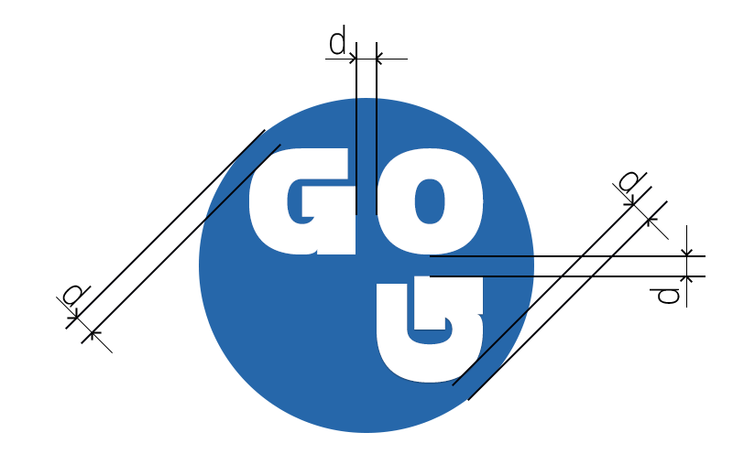

#### Square badge

##### Example



##### Sizes



#### Typography

Use the logo font with the following setup:

Vertical scale: 100%

Horizontal scale: 100%

#### Colour pallette



### Social networks

#### Cover image



#### Profile image

The profile image for the social networks is identical to the square badge.



### Mobile applications

#### Icon

The icon for the mobile app is identical to the square badge.



### Website

#### Colour pallette



#### Fonts

Use “Open Sans”.

## Typical signs (Characteristics)

The typical signs of the systems are:

* Collaborative system where the people can find each other and may do or create something together.
* Evaluation mechanism of the people, providing quality.

## Associations

The key associations connected to *PeopleGoGo* are the words:

* together;
* collaborate;

## Communication with the client

### Video advertisement

For the video materials there are no limitation for the usage of the female or male voices.